DIGESTIVE SYSTEM
Due to the different diets, digestive system and digestive process in animals can vary among herbivores, carnivores and omnivores.

Most of mammals have in common the following parts in their digestive system.

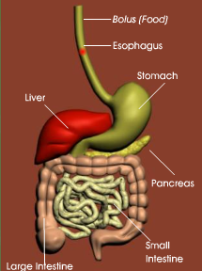
- Mouth: here the food is chewed with the teeth and mixed with saliva forming the
bolus.
- The Esophagus: Is the tube that conducts the bolus to the stomach
- In the stomach, food is chummed and mixed by the action of gastric acid producing
the chime.
- Small intestine the food becomes simple substances thanks to the intestinal fluids,
pancreatic enzymes and the bile. Here the nutrients pass to the blood, to all parts
of the body, through the intestinal hair.
- Large Intestine: here the water is reabsorbed and the wastes of the digestive tract,
feces, become solid and are stored until they can be eliminated.

Differences in mammalian digestive systems

Carnivores:
- Wide mouth opening
- Spaced teeth
- Incisors are short while canines are greatly elongated.
The digestive systems with complex stomachs have four separate compartments: reticulum, omasum, abomasums and rumen.
It is present in herbivores such as cows, sheeps and goats.
Complex

Simple

Carnivores as tigers, lions, wolves, etc

Omnivores as humans, swine, bears, etc.

Simple

Stomach

Oral cavity

Simple with Cecum

Herbivores:
- Teeth closely grouped.
- The incisors form their bite mechanism
- Use actively tongue and cheek muscles to chew their food.
The Cecum is a special compartment that helps in digestion process.
It can be found in herbivores such as horses, rabbits and guinea pigs

These animals are called ruminants because their digestion involves the process of rumination: swallowing, “un swallowing”, re-chewing and re-swallowing.
Omnivores:
- Variety of teeth (canines, incisors, premolars and molars) because they eat variety of foods (meat and plants).

OTHER DIGESTIVE SYSTEMS
Avian digestive system
Reptile digestive system
Amphibian digestive system
Fish digestive system

Their oral cavity secretes venoms and substances that aid in digestion
Their digestive system consists of esophagus, stomach, small intestine gall bladder and large intestine.
Fish have a jawed mouth and teeth.
Beak replaces the lips and teeth of mammals.

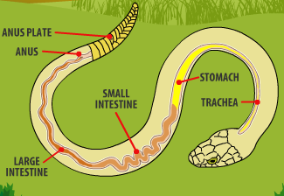
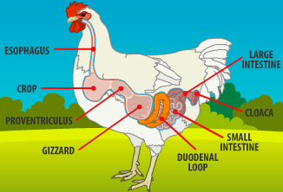
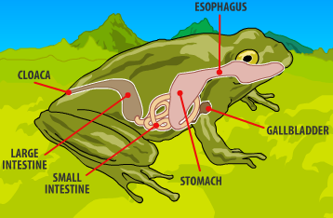
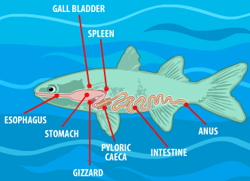
Their large intestine is known as cloaca.
The stomach is divided in two portions; one of them is the gizzard that helps in the grinding process.
The large intestine is formed by a large cecum, colon and rectum
The structure of the stomach suggests a triturating function.
The esophagus can serve as storage area during gastric digestion of large preys.
They can have a gizzard to grind the before it passes to the intestine where digestion process is completed.
Have an enlarged crop that serves as temporary storage of food.

